# NAS Cyber Actuarial Memo

2018-06-06

Dion Oryzak FCAS

Amit Verma ACAS

## Reliance and Limitations

This draft report is for discussion purposes only and should not be relied upon for any other purpose. This report should not be distributed outside NAS.

## NAS Cyber Pricing Loss Cost Model

This report outlines a loss cost model for NAS’s Cyber insurance program. Experience from NAS’s open market and reinsurance programs from the 2013- 2018 years were combined for modeling NAS’ Cyber Insurance loss costs for the purpose of supporting state filings. Claim frequency and claim severity was modelled for each of the Cyber (CYB) and Medefense (MED) coverages separately. The Summary Statistics exhibit summarizes the overall number of exposures, claim count, claim cost, claim frequency and claim severity for each of these two coverage groupings.

Summary Statistics

|  |  |  |
| --- | --- | --- |
| Cyber | Exposure | *1,011,319* |
| Claim Count | *2,163* |
| Claim Cost | *$43,763,362* |
| Claim Frequency | *0.21%* |
| Average Claim Severity | *$20,233* |
| Medefense | Exposure | *147,526* |
| Claim Count | *630* |
| Claim Cost | *$9,838,242* |
| Claim Frequency | *0.43%* |
| Average Claim Severity | *$15,616* |

Consistent with industry practice, claim frequency was modeled using a log link function and a Poisson error distribution, while claim severity was modelled using a log link function and a Gamma error distribution. Appendix 1 outlines the approach taken to data preparation and modeling. Appendix 2 shows the raw model output and shows actual vs fitted charts for each factor tested.

Factors tested for each coverage include:

* log_CyberLimit: The natural logarithm of the per claim limit for the Cyber coverage
* log_MedefenseLimit: The natural logarithm of the per claim limit for the Medefense coverage
* missing_Revenue: A 0/1 boolean flag indicating that Insured Revenue was Missing or Unknown
* log_Revenue: The natural logarithm of Insured Revenue. Where Insured Revenue is Unknown this factor was set to -1
* missing_NumberPhysicians: A 0/1 boolean flag indicating that the number of insured physicians was Missing or Unknown
* log_ NumberPhysicians: The natural logarithm of the Number of Physicians covered by a policy. Where Number of Physicians is Unknown this factor was set to -1
* BothCoverages: A 0/1 boolean flag indicating that an exposure unit had both the Cyber and Medefense coverages

For **open market policies** each exposure covers a specified number of Physicians (where relevant) but all covered Physicians share the same policy limit, so the policy is a single unit of exposure while the Number of Physicians behaves like a rating factor. By contrast, for **reinsurance treaties** each covered Physician has their own independent limit, so each individual Physician is treated as a single unit of exposure and the ‘NumberPhysicians’ factor is set to 1.

The beta parameters for the four models are outlined in the Model Beta Parameters exhibit. Not all factors were significant for all models.

Model Beta Parameters

|  |  |  |  |  |
| --- | --- | --- | --- | --- |
|  | **CYB Frequency** | **CYB Severity** | **MED Frequency** | **MED Severity** |
| Intercept | -15.7898 | 9.7008 | -7.6216 | -1.1142 |
| log_CyberLimit | 0.4209 |  |  |  |
| log_MedefenseLimit |  |  |  | 0.3898 |
| missing_Revenue | 5.1374 |  | 3.0456 | 7.271 |
| log_Revenue | 0.3332 |  | 0.2222 | 0.4386 |
| missing_NumberPhysicians |  | 2.0359 |  |  |
| log_NumberPhysicians |  | 0.7169 |  |  |
| BothCoverages |  |  | -0.7067 |  |

The two-way tables below illustrate how these model parameters translate into loss costs as either:

* Limit and Insured Revenue varies while Number of Physicians is held constant (at ‘Unknown’ value); OR
* Limit and Number of Physicians varies while Insured Revenue remains constant (at ‘Unknown’ value) for MED only

CYB Loss Costs by Limit and Insured Revenue

|  |  |  |  |  |  |  |  |  |  |
| --- | --- | --- | --- | --- | --- | --- | --- | --- | --- |
|  |  | **Limit** |  |  |  |  |  |  |  |
|  |  | **$10,000** | **$25,000** | **$50,000** | **$ 100,000** | **$ 250,000** | **$500,000** | **$ 1,000,000** | **$ 2,000,000** |
| **Revenue** | **$ 100,000** | $ 19 | $ 28 | $ 37 | $ 50 | $ 74 | $ 98 | $ 132 | $ 176 |
| **$ 1,000,000** | $ 41 | $ 60 | $ 80 | $ 108 | $ 158 | $ 212 | $ 284 | $ 380 |
| **$ 10,000,000** | $ 88 | $ 129 | $ 173 | $ 232 | $ 341 | $ 457 | $ 611 | $ 818 |
| **$ 100,000,000** | $ 190 | $ 279 | $ 373 | $ 499 | $ 735 | $ 983 | $ 1,316 | $ 1,762 |
| **$ 1,000,000,000** | $ 408 | $ 600 | $ 804 | $ 1,076 | $ 1,582 | $ 2,118 | $ 2,835 | $ 3,796 |
| **Unknown** | $ 50 | $ 73 | $ 98 | $ 132 | $ 194 | $ 259 | $ 347 | $ 464 |

CYB Loss Costs by Limit and Number of Physicians

|  |  |  |  |  |  |  |  |  |  |
| --- | --- | --- | --- | --- | --- | --- | --- | --- | --- |
|  |  | **Limit** |  |  |  |  |  |  |  |
|  |  | **$10,000** | **$25,000** | **$ 50,000** | **$100,000** | **$250,000** | **$ 500,000** | **$ 1,000,000** | **$ 2,000,000** |
| **Number of Physicians** | **1** | $ 13 | $ 20 | $ 26 | $ 35 | $ 52 | $ 69 | $ 93 | $ 124 |
| **2** | $ 22 | $ 32 | $ 43 | $ 58 | $ 85 | $ 114 | $ 152 | $ 204 |
| **5** | $ 42 | $ 62 | $ 83 | $ 112 | $ 164 | $ 220 | $ 294 | $ 394 |
| **10** | $ 70 | $ 102 | $ 137 | $ 183 | $ 270 | $ 361 | $ 483 | $ 647 |
| **100** | $ 363 | $ 533 | $ 714 | $ 956 | $ 1,405 | $ 1,882 | $ 2,519 | $ 3,372 |
| **Unknown** | $ 50 | $ 73 | $ 98 | $ 132 | $ 194 | $ 259 | $ 347 | $ 464 |

MED Loss Costs by Limit and Insured Revenue

|  |  |  |  |  |  |  |  |  |  |
| --- | --- | --- | --- | --- | --- | --- | --- | --- | --- |
|  |  | **Limit** |  |  |  |  |  |  |  |
|  |  | **$ 10,000** | **$ 25,000** | **$50,000** | **$100,000** | **$250,000** | **$500,000** | **$1,000,000** | **$2,000,000** |
| **Revenue** | **$ 100,000** | $ 12 | $ 17 | $ 22 | $ 29 | $ 41 | $ 54 | $ 71 | $ 93 |
| **$ 1,000,000** | $ 54 | $ 77 | $ 101 | $ 132 | $ 188 | $ 247 | $ 323 | $ 424 |
| **$ 10,000,000** | $ 246 | $ 352 | $ 461 | $ 604 | $ 863 | $ 1,130 | $ 1,481 | $ 1,940 |
| **$ 100,000,000** | $ 1,126 | $ 1,610 | $ 2,109 | $ 2,764 | $ 3,950 | $ 5,175 | $ 6,781 | $ 8,884 |
| **$ 1,000,000,000** | $ 5,158 | $ 7,372 | $ 9,659 | $ 12,656 | $ 18,089 | $ 23,700 | $ 31,052 | $ 40,685 |
| **Unknown** | $ 91 | $ 130 | $ 170 | $ 223 | $ 319 | $ 418 | $ 547 | $ 717 |

A 50% discount also applies to the MED loss costs if both the CYB and MED coverages are taken

## Appendix 1 – Approach

1. From the PolicyData-5.9.18 file (sent by NAS on 2018-05-09), policy/exposure records were dropped where:
   1. Program Type is 'rein', or 'reinbu'
   2. Policy status is inactive, pending or cancelled
   3. No exposure exists (because start date equals end date)
   4. Exposure record is a duplicate
2. Following discussion with NAS, extreme outliers and data errors for the Number of Physicians and Insured Revenue fields were set to Unknown (i.e. 0). Note that for open market policies, Number of Physicians is treated as a rating factor since each policy shares its limit across all physicians covered by that policy.
3. Reinsurance treaty exposures from file REIN_Exposure_v2 (sent by NAS on 2018-05-26) were appended to the Open Market program exposures, but for all reinsurance treaties the Number of Physicians per exposure was set to 1 and Insured Revenue set to 0 (Unknown). Note that for reinsurance treaties, each covered physician is treated as a separate unit of exposure because each covered physician possesses its own limit
4. From the claims file ClaimsData-5.9.18 (sent by NAS on 2018-05-09), all non-zero cost claims were deleted and joined to the exposure file. The Summary Statistics exhibit displays summary statistics for the data successfully joined. The Non-zero Cost Claims exhibit shows all claims (of non-zero cost) from the claims file and the percentage of claims that were successfully joined to exposure units.
5. Incurred losses as provided (including case estimates) were adopted. No explicit development of losses was performed.
6. Models for claim frequency and claim severity were developed separately for each of Cyber and Medefense claims. Log links were used for all GLMs. The claim frequency models used a Poisson error distribution. The claim severity models used a Gamma error distribution.
7. Although the majority of the exposure lies with the Reinsurance treaties, which don’t have an Insured Revenue factor (therefore being set to Unknown) or Number of Physicians factor (therefore being set to 1), enough exposure does lie in the open market programs to develop sensible factors for the Insured Revenue and Number of Physicians curves.

Summary Statistics

|  |  |  |  |  |  |  |
| --- | --- | --- | --- | --- | --- | --- |
|  |  | **omprog** | **open** | **prog** | **Reinsurance Treaty** | ***Total*** |
| Cyber | Exposure | 1,580 | 16,737 | 7,821 | 985,182 | *1,011,319* |
| Claim Count | 18 | 266 | 33 | 1,846 | *2,163* |
| Claim Cost | $937,322 | $14,113,149 | $5,358,225 | $23,354,665 | *$43,763,362* |
| Claim Frequency | 1.14% | 1.59% | 0.42% | 0.19% | *0.21%* |
| Average Claim Severity | $52,073 | $53,057 | $162,370 | $12,651 | *$20,233* |
| Medefense | Exposure | 15 | 3,429 | 6,459 | 137,623 | *147,526* |
| Claim Count | - | 43 | 27 | 560 | *630* |
| Claim Cost | $- | $1,442,959 | $3,088,541 | $5,306,742 | *$9,838,242* |
| Claim Frequency | 0.00% | 1.25% | 0.42% | 0.41% | *0.43%* |
| Average Claim Severity |  | $33,557 | $114,390 | $9,476 | *$15,616* |

Non-zero Cost Claims

|  |  |  |  |  |  |  |  |  |
| --- | --- | --- | --- | --- | --- | --- | --- | --- |
|  |  | **omprog** | **open** | **prog** | **rein** | **reinbu** | **Total** | **Percentage mapped to valid exposure** |
| Cyber | Total Claim Count | 20 | 269 | 662 | 2025 | 10 | 2986 | 72% |
| Total Claim Cost | $988,778 | $14,143,690 | $10,447,332 | $27,570,887 | $850,532 | $54,001,219 | 81% |
| Medefense | Total Claim Count | 0 | 54 | 56 | 641 | 23 | 774 | 81% |
| Total Claim Cost | $- | $1,497,751 | $3,381,328 | $6,966,615 | $3,721,381 | $15,567,075 | 63% |

## Appendix 2 – GLM Model Results

### Cyber Frequency

Generalized Linear Model Regression Results

==============================================================================

Dep. Variable: CYBClaimCount No. Observations: 26222

Model: GLM Df Residuals: 26218

Model Family: Poisson Df Model: 3

Link Function: log Scale: 1.0

Method: IRLS Log-Likelihood: -2446.9

Date: Wed, 06 Jun 2018 Deviance: 3780.0

Time: 11:59:59 Pearson chi2: 3.15e+04

No. Iterations: 7

===================================================================================

coef std err z P>|z| [0.025 0.975]

-----------------------------------------------------------------------------------

Intercept -15.7898 0.602 -26.247 0.000 -16.969 -14.611

missing_Revenue 5.1374 0.477 10.779 0.000 4.203 6.072

log_Revenue 0.3332 0.027 12.369 0.000 0.280 0.386

log_CyberLimit 0.4209 0.039 10.773 0.000 0.344 0.497

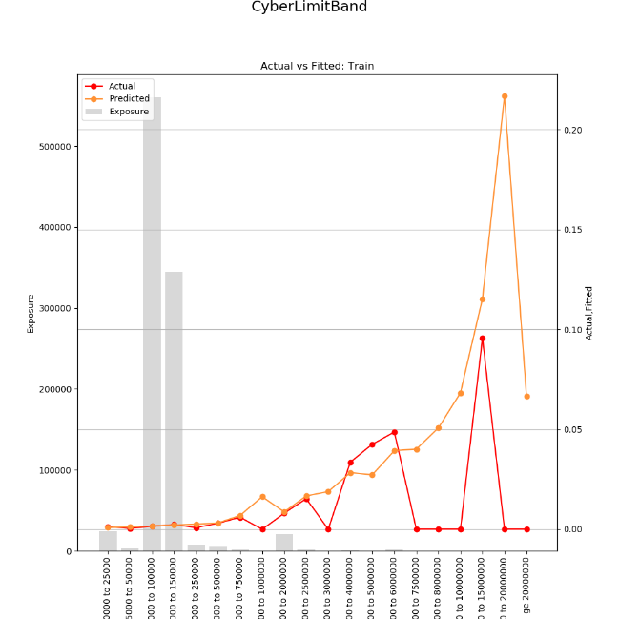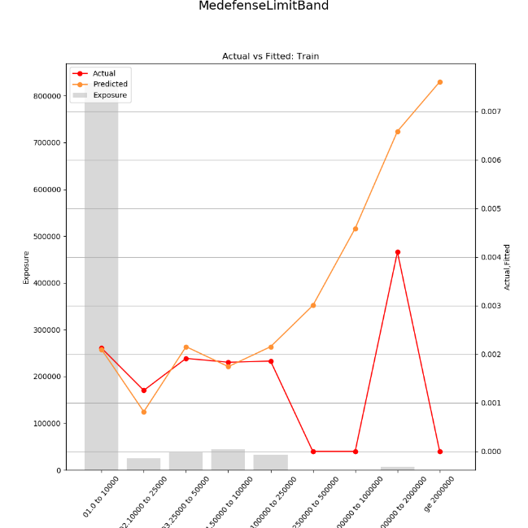

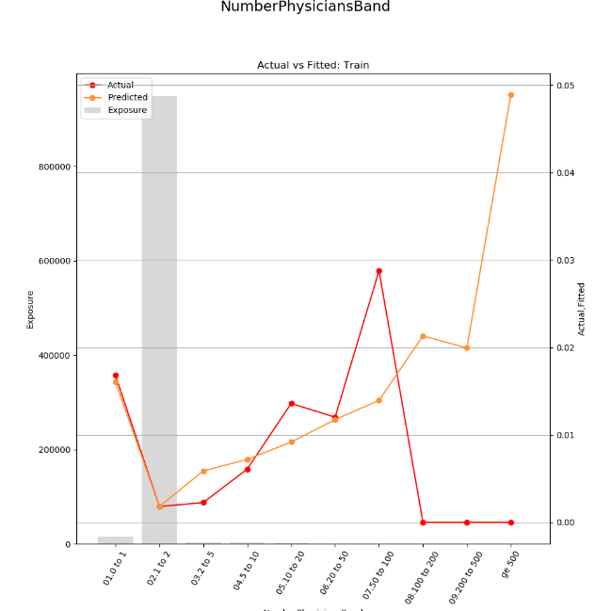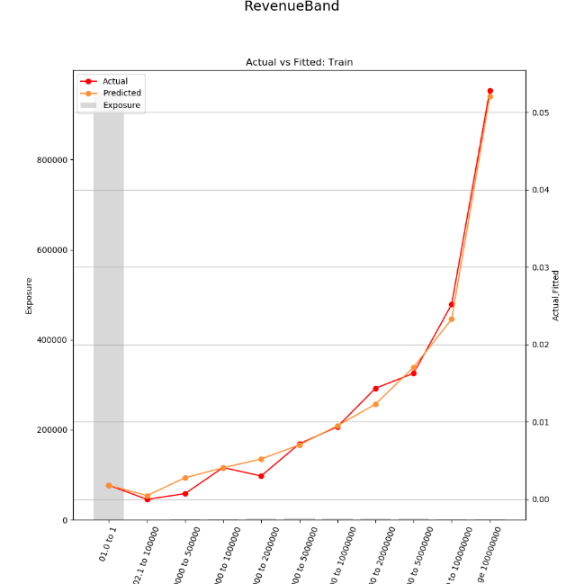

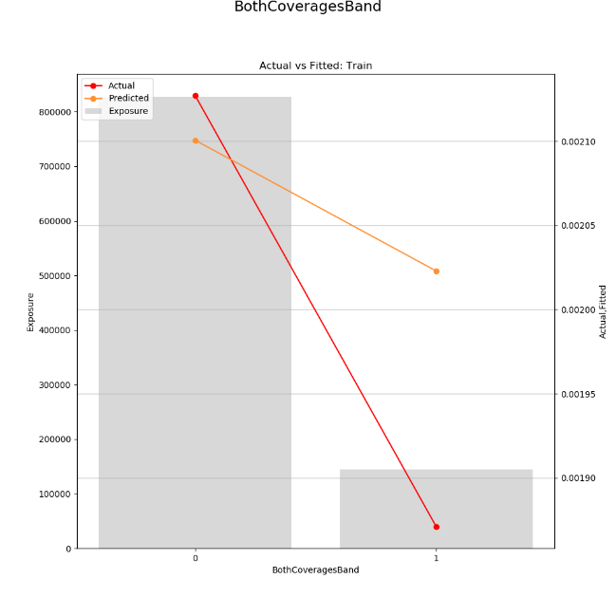

### Cyber Severity

Generalized Linear Model Regression Results

==============================================================================

Dep. Variable: CYBClaimCost No. Observations: 432

Model: GLM Df Residuals: 429

Model Family: Gamma Df Model: 2

Link Function: log Scale: 4.18429369903

Method: IRLS Log-Likelihood: -5347.0

Date: Wed, 06 Jun 2018 Deviance: 841.27

Time: 12:00:02 Pearson chi2: 1.80e+03

No. Iterations: 7

coef std err z P>|z| [0.025 0.975]

--------------------------------------------------------------------------------------------

Intercept 9.7008 0.161 60.298 0.000 9.385 10.016

missing_NumberPhysicians 2.0359 0.283 7.200 0.000 1.482 2.590

log_NumberPhysicians 0.7169 0.134 5.345 0.000 0.454 0.980

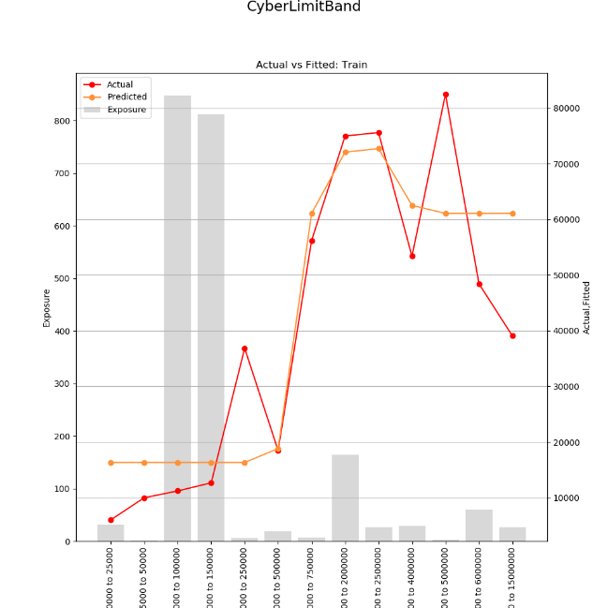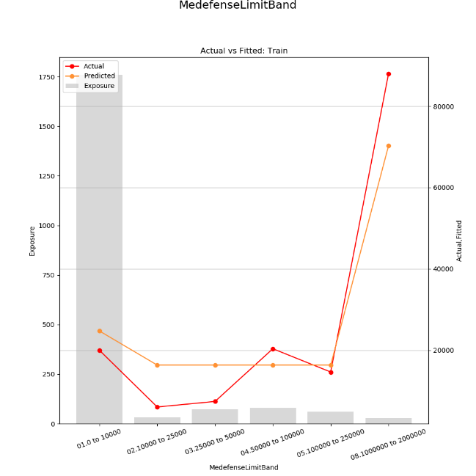

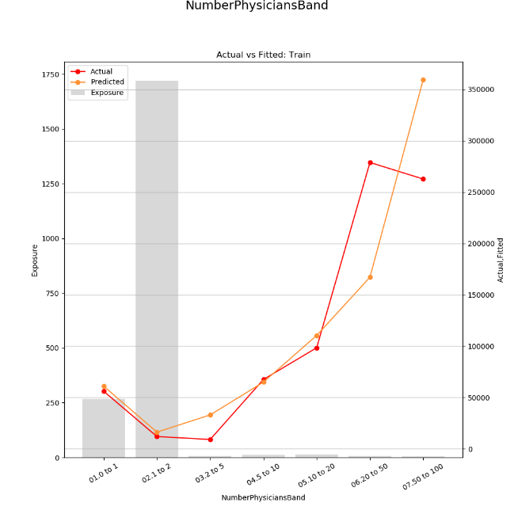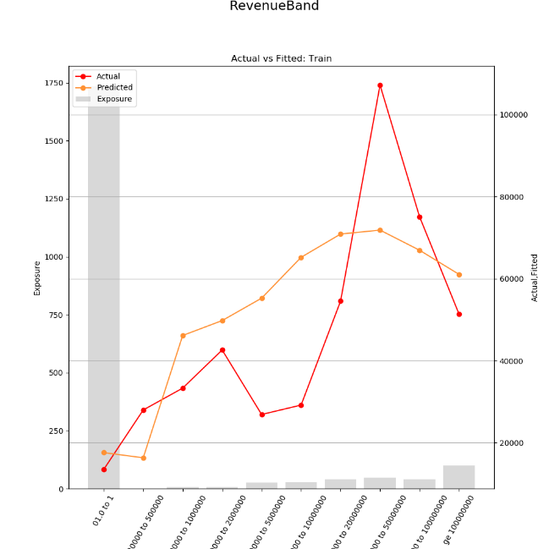

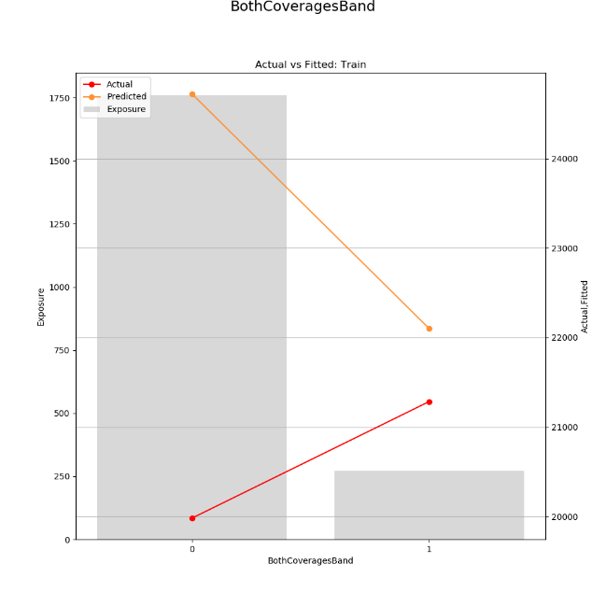

### Medefense Frequency

Generalized Linear Model Regression Results

==============================================================================

Dep. Variable: MEDClaimCount No. Observations: 9928

Model: GLM Df Residuals: 9924

Model Family: Poisson Df Model: 3

Link Function: log Scale: 1.0

Method: IRLS Log-Likelihood: -863.15

Date: Wed, 06 Jun 2018 Deviance: 1497.9

Time: 12:00:04 Pearson chi2: 1.51e+04

No. Iterations: 7

===================================================================================

coef std err z P>|z| [0.025 0.975]

-----------------------------------------------------------------------------------

Intercept -7.6216 1.438 -5.298 0.000 -10.441 -4.802

missing_Revenue 3.0456 1.523 1.999 0.046 0.060 6.031

log_Revenue 0.2222 0.093 2.395 0.017 0.040 0.404

BothCoverages -0.7067 0.216 -3.272 0.001 -1.130 -0.283

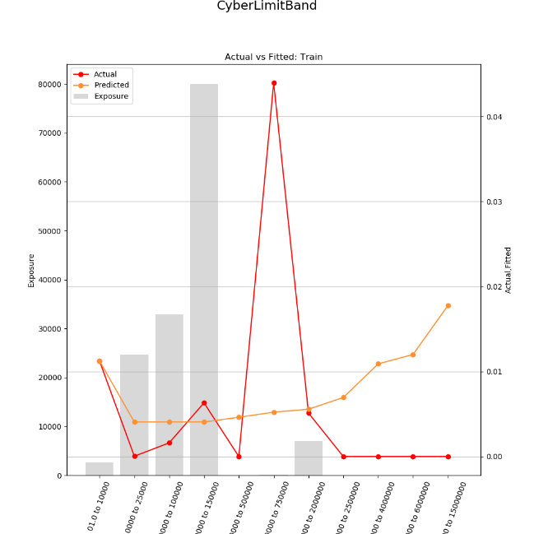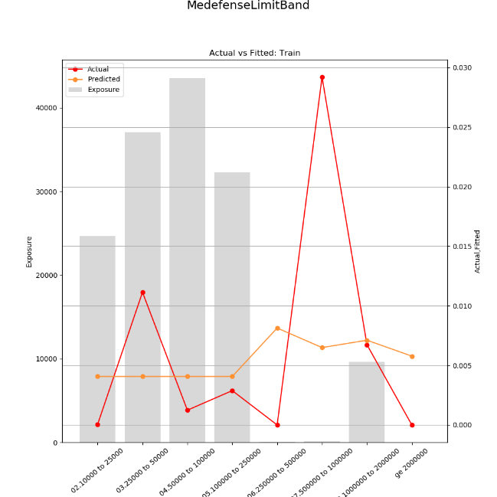

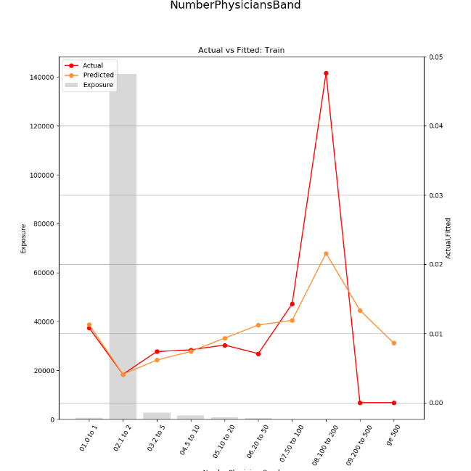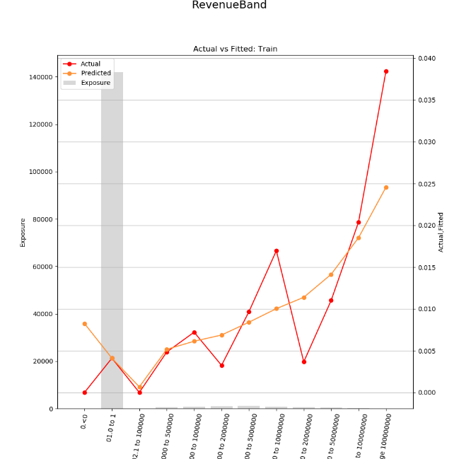

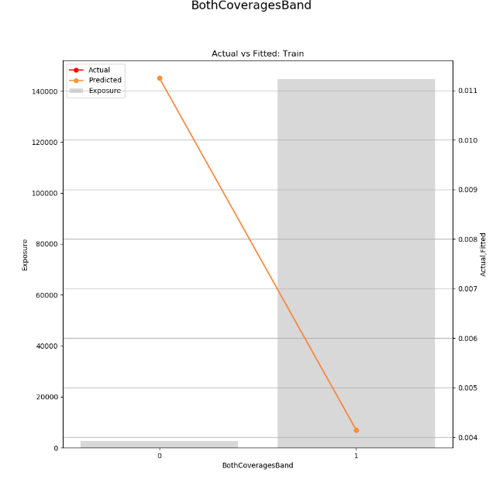

### Medefense Severity

Generalized Linear Model Regression Results

==============================================================================

Dep. Variable: MEDClaimCost No. Observations: 89

Model: GLM Df Residuals: 85

Model Family: Gamma Df Model: 3

Link Function: log Scale: 2.51207238052

Method: IRLS Log-Likelihood: -1099.0

Date: Wed, 06 Jun 2018 Deviance: 140.34

Time: 12:00:08 Pearson chi2: 214.

No. Iterations: 9

======================================================================================

coef std err z P>|z| [0.025 0.975]

--------------------------------------------------------------------------------------

Intercept -1.1142 3.225 -0.346 0.730 -7.435 5.206

missing_Revenue 7.2710 2.621 2.774 0.006 2.133 12.409

log_Revenue 0.4386 0.157 2.785 0.005 0.130 0.747

log_MedefenseLimit 0.3898 0.153 2.553 0.011 0.090 0.689

======================================================================================

